**CREATION OF CUSTOM BASE IMAGES**

For the purpose of handling our own projects in their respective pipelines, it is needed to create the images that they are going to reside in with al the required dependencies, for that purpose we will use DockerFiles, a file in charge of telling docker how the custom image should be created, having the next content for the juiceShop pipeline:

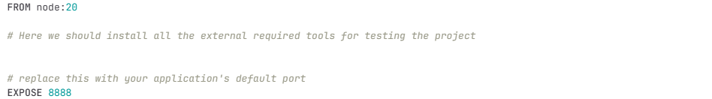

* we base the image on the maven image of the specific version for our Project, in this case the node:20, which does not have a conflict with our Project.